**5376. 【NOIP2017提高A组模拟9.19】Candy  (File IO): input:carry.in output:carry.out**

Time Limits: **1000 ms**  Memory Limits: **262144 KB**  Detailed Limits

**Description**

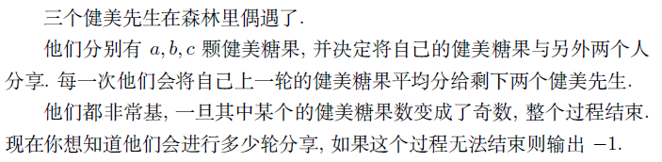

**Input**

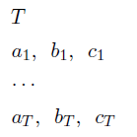

**Output**



**Sample Input**

2

2 2 2

4 6 8

**Sample Output**

-1

1

**Data Constraint**

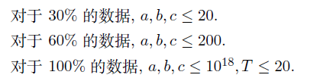

**5377. 【NOIP2017提高A组模拟9.19】开拓  (File IO): input:exploit.in output:exploit.out**

Time Limits: **1000 ms**  Memory Limits: **262144 KB**  Detailed Limits

[Goto ProblemSet](https://jzoj.net/senior/#main/show/5377)

**Description**

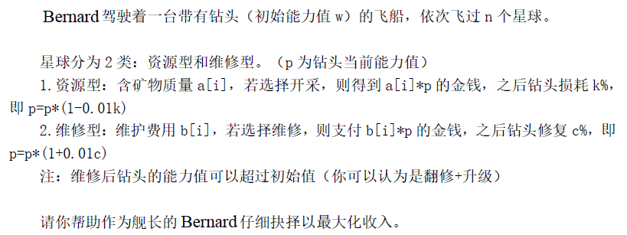

**Input**

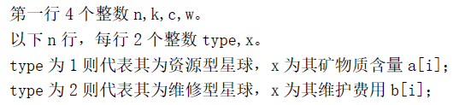

**Output**



**Sample Input**

5 50 50 10

1 10

1 20

2 10

2 20

1 30

**Sample Output**

375.00

**Data Constraint**

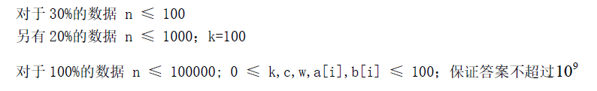

**5378. 【NOIP2017提高A组模拟9.19】闷声刷大题  (File IO): input:orz.in output:orz.out**

Time Limits: **3000 ms**  Memory Limits: **524288 KB**  Detailed Limits

**Description**

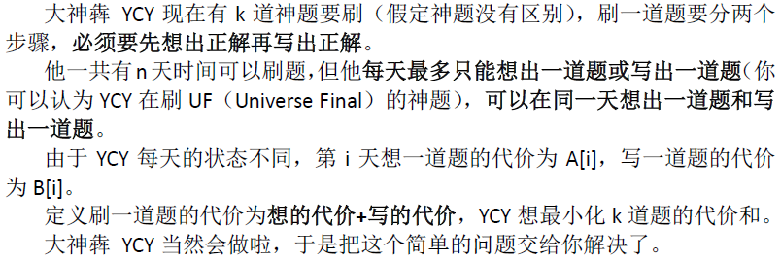

**Input**

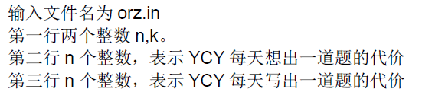

**Output**



**Sample Input**

10 5

2 5 610 5 8 9 2 6 1

6 6 5 5 7 7 3 6 8 6

**Sample Output**

40

**Data Constraint**

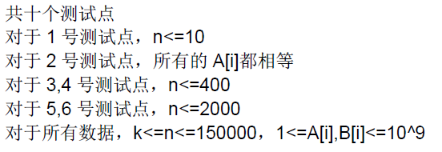

**Hint**

